**Publication**

1. The bulletin board thumbnail button shows notifications available that can be accessed from the bulletin board.
2. The Subscription board displays a list of rendered subscription reports that have been posted to the user's "in-box" that the user has subscribed to (discover reports and present dashboard)
3. The Publication board displays a list of rendered publication reports that have been posted to the user's "in-box" that the user has subscribed to

The Subscription board displays a list of rendered subscription reports that have been posted to the user's "in-box"

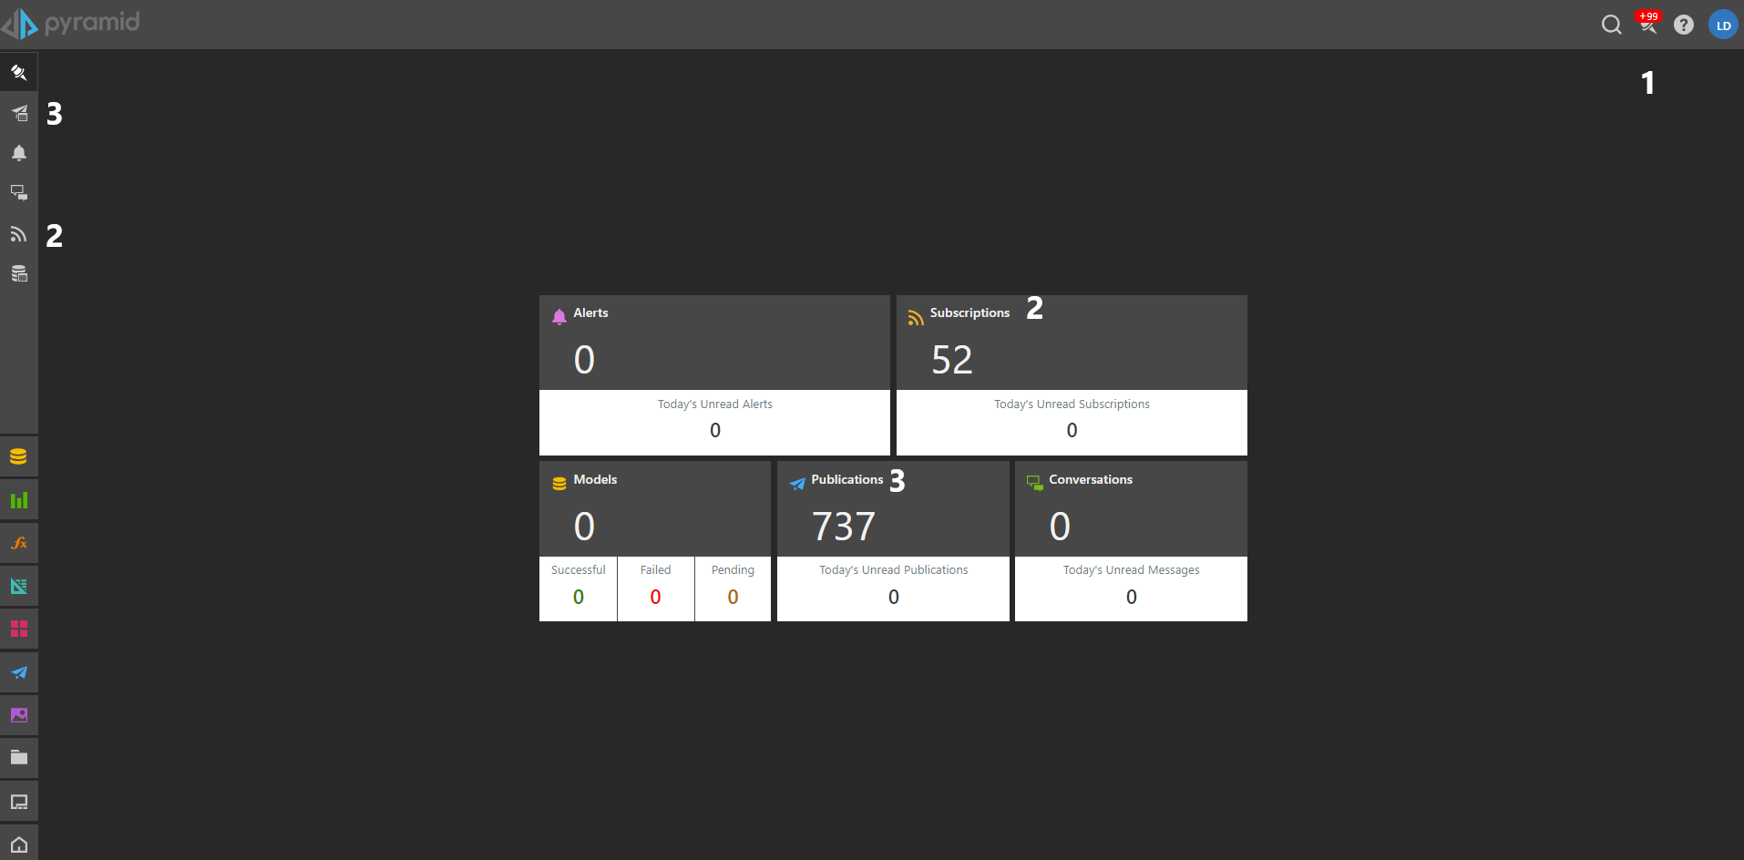

To check on the publication subscriptions, click on (3) and it will show a list of all the publications you have subscribed to.

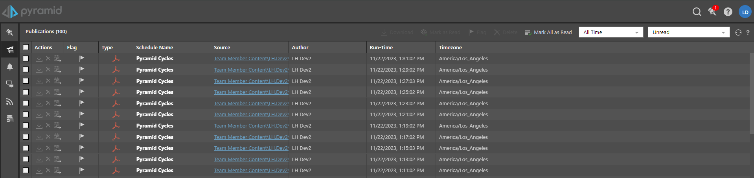

Within actions (left most side), you can download or delete the publication output or go to the exact location of the publication (3rd button under actions column)